**EXPERIMENT-14**

**Title:  To understand the concepts of function and procedure in PL/SQL.**

**Objective:** Students will be able to implement the Pl/SQL programs using function and procedure.

1. Implement the above experiments of PL/SQL using functions and procedures.

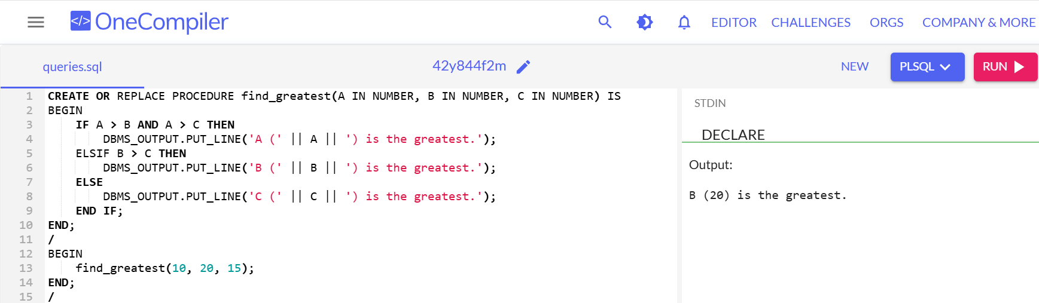

(b)

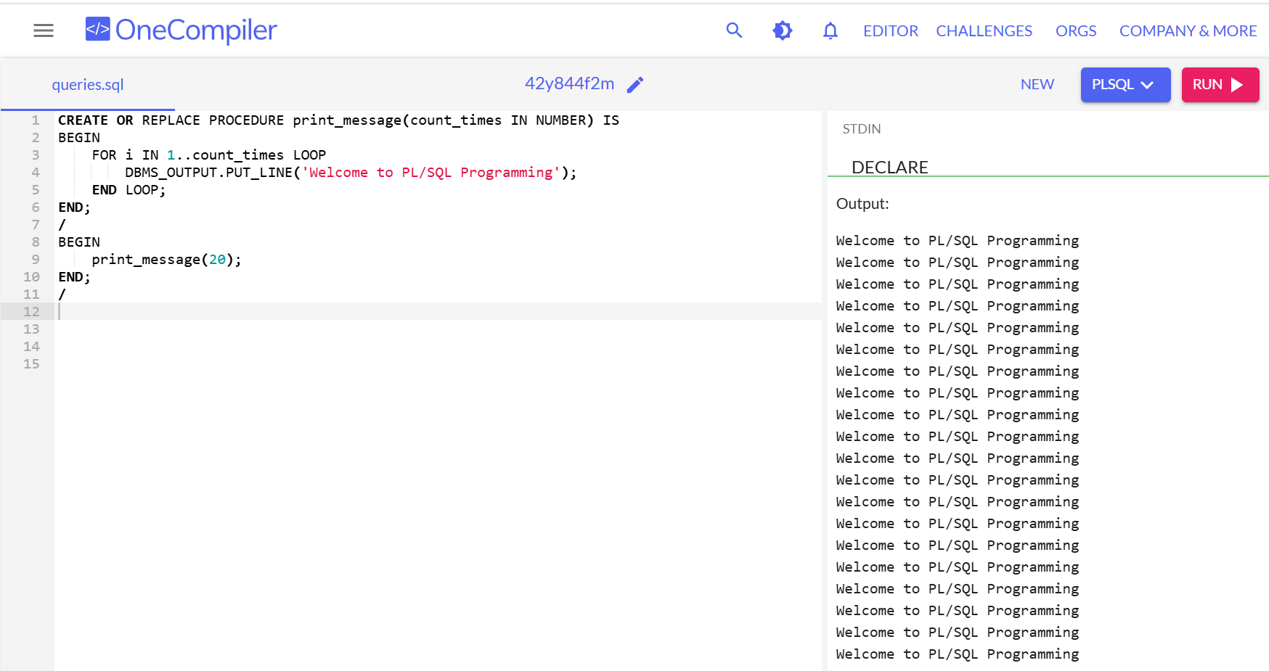

(c)

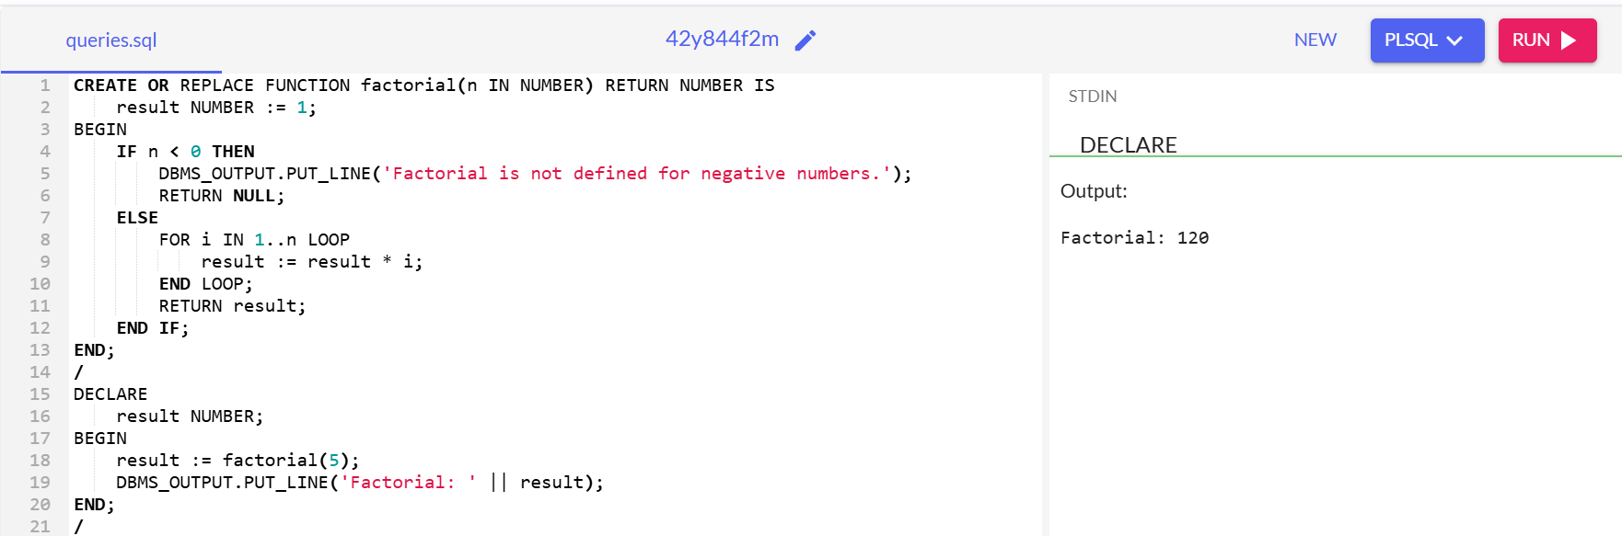

(d)

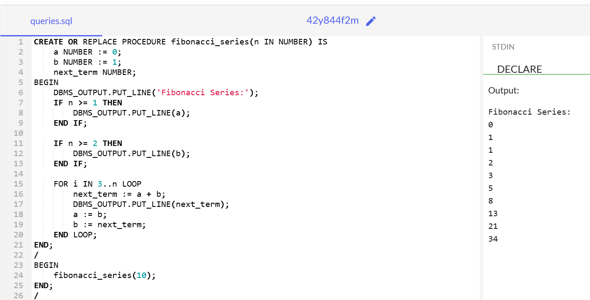

(e)

